Seminor Report
Title:ELECTRONIC SKIN
Name:T.LAKSHMI DURGA
Roll:23NG5A0427
Abstract:
Electronic skin (e-skin) is a rapidly emerging class of flexible, stretchable, and self-healing materials designed to mimic the sensory and functional capabilities of human skin. Integrating advanced materials science, nanotechnology, and electronics, e-skin systems are capable of detecting stimuli such as pressure, temperature, humidity, and strain with high sensitivity and resolution.

Introduction:

Electronic skin, commonly known as e-skin, is an innovative class of flexible, stretchable, and sometimes self-healing electronic systems designed to replicate the sensory functions of human skin. By integrating various sensors and flexible circuits, e-skin can detect environmental stimuli such as pressure, temperature, humidity, and motion, making it highly valuable for healthcare, robotics, and wearable technologies.

Working Principle:
Electronic skin, commonly known as e-skin, is an innovative class of flexible, stretchable, and sometimes self-healing electronic systems designed to replicate the sensory functions of human skin. By integrating various sensors and flexible circuits, e-skin can detect environmental stimuli such as pressure, temperature, humidity, and motion, making it highly valuable for healthcare, robotics, and wearable technologie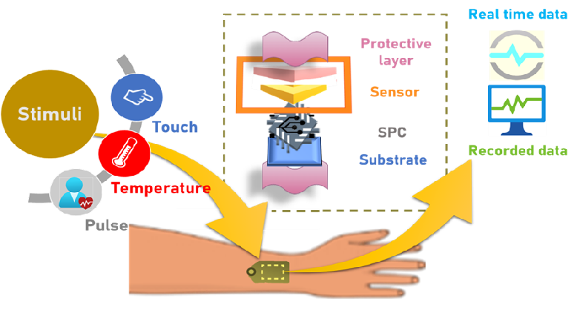
Advantages:
- Real-time vital sign monitoring
- Remote patient monitoring
- Personalized healthcare
- Wound care

Disadvantages:
- Expensive materials like graphene and CNTs
- Limited durability in harsh environments
- Complex to manufacture at large scale
- Needs external electronics for full system integration

4. Applications:

1. Healthcare Monitoring

2. Prosthetics and Human-Machine Interfaces

3. Robotics

4. Wearable Technology

Future Scope:
  - Self-healing materials that repair damage
  - Wireless E-skin networks for full-body sensing
  - Integration with AI for real-time decision making
  - Energy-harvesting e-skins for battery-free operation

CONCLUSION:

Electronic skin represents a significant technological leap in mimicking human tactile and sensory perception. With continued interdisciplinary collaboration and innovation, e-skin is poised to become an integral component of smart healthcare, advanced prosthetics, and next-generation robotics

Thank you

